Project Report

**=>Project Title**

Grocery Android App

**=>Objective**

Make a Grocery App that can help you in managing your Grocery list.

**=>Problem Statement**

As we can't remember everything, users frequently forget to buy the things they want to buy. However, with the assistance of this app, you can make a list of the groceries you intend to buy so that you don't forget anything.

**=>Problem's Primary Goals**

Our Primary Goal is to give the user the functionality of adding items in a cart like interface and give him the ability to add or remove items from this list to better manage his groceries.

**=>Introduction**

We will be making a simple cart like layout where an add button will give you a popup to add the items and a delete button will remove the selected item from the list resulting in recalculation of the total expenditure of the remaining items in the cart!

**=>Procedure**

* Create the project from a template﻿
* Examine the project structure﻿.
* Run your application to see everything is working or not.
* Start from creating the base layout.
* Create the item interface.
* Add the button.
* Create the popup interface.
* Write the logic to add items to the cart.
* Write the logic to remove items from the cart.
* Write the logic to calculate the total expenditure incurred by grocery items.
* Test your code for bugs.
* Deploy!

**=>Expected Outcome**

* Open the Grocery Maker App with Green icon

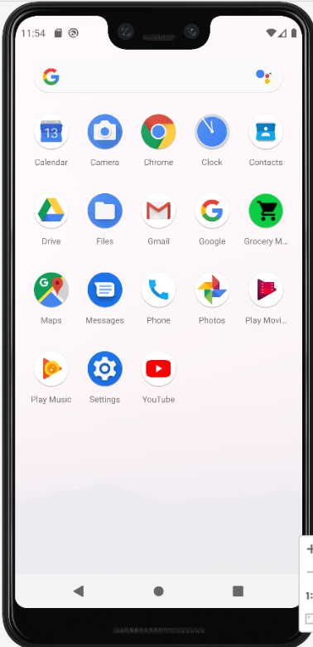

* The cart is empty! Let’s add few groceries here.

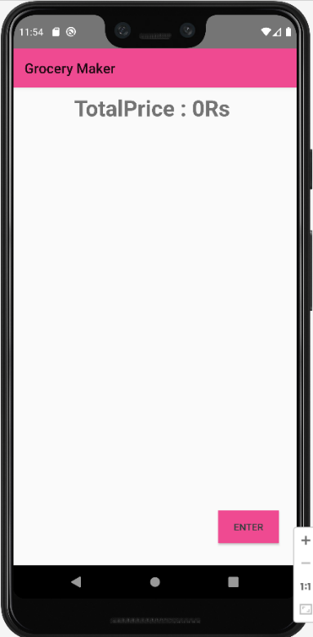

* A popup box appears after clicking on Enter button in corner.

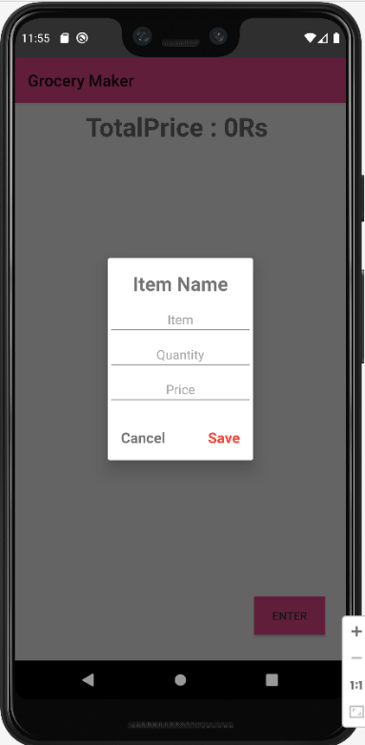

* Fill the Grocery item, their Quantity and total price in the field.

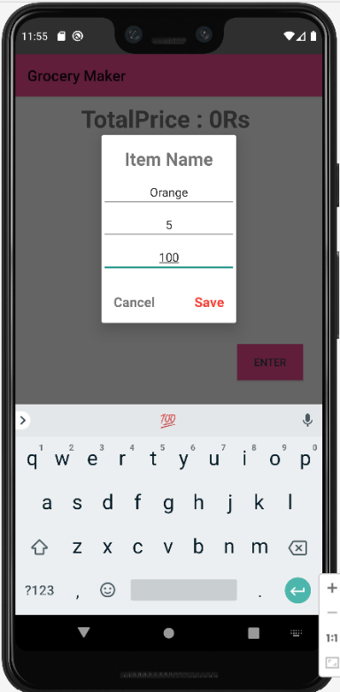

* Your first Grocery item is in the list!

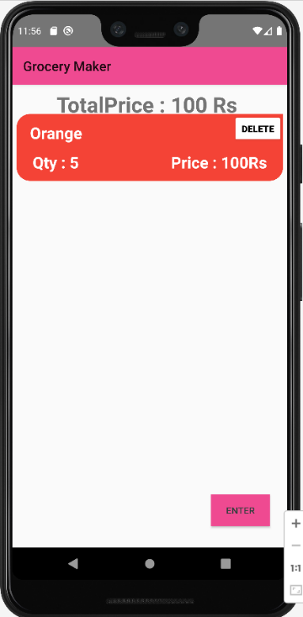

* Add few more Grocery items to the List & see the Total Price change.

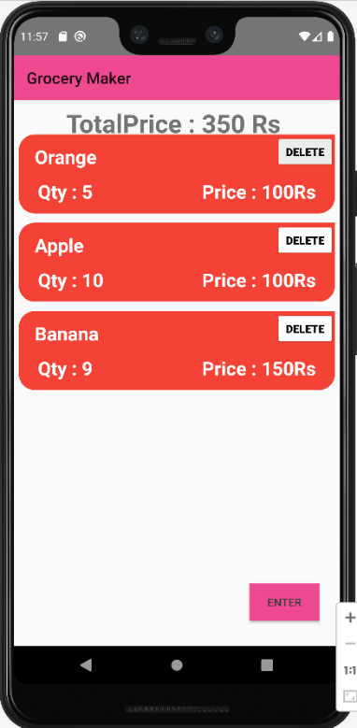

* Check the subtraction logic by clicking on DELETE button.

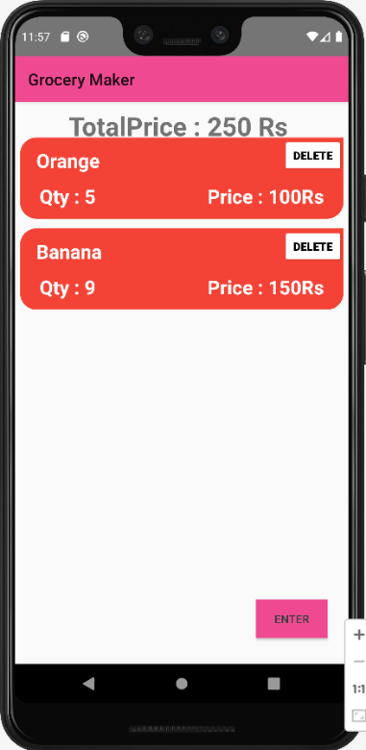

* Removing everything brings our Total Price back to 0

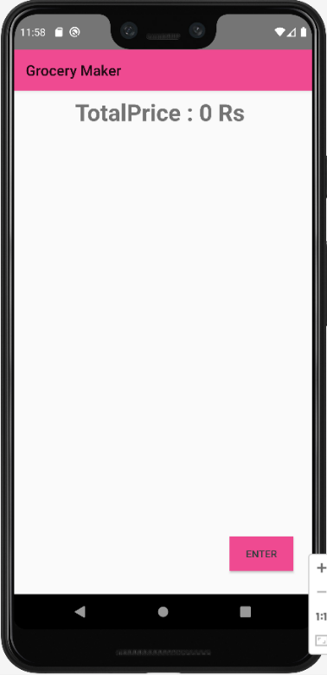

**=>Technologies Used**

* Android Studio
* Kotlin

**=>URLs**

1)GitHub URL

* <https://github.com/smartinternz02/SPSGP-73358-Virtual-Internship---Android-Application-Development-Using-Kotlin>

2)Video Demo URL

* <https://www.youtube.com/watch?v=rPZPAe-Cc_s>

**=>Account IDs**

1)GitHub ID

* <https://github.com/souviksamanta007>

2)SmartInternz ID

* Username: [souviksamanta070@gmail.com](mailto:souviksamanta070@gmail.com)

**=>Acknowledgements**

* <https://www.geeksforgeeks.org/guide-to-install-and-set-up-android-studio/>
* <https://www.youtube.com/watch?v=vdcLb_Y71Ic>
* <https://www.youtube.com/watch?v=p2oHD-06YcM>
* <https://www.youtube.com/watch?v=LgRRmgfrFQM>
* <https://developer.android.com/>
* <https://devlibrary.withgoogle.com/products/android>
* <https://kotlinlang.org/>
* <https://developers.google.com/certification/associate-android-developer>
* <https://developers.google.com/community/gdsc>
* <https://developers.google.com/community/gdg>
* <https://developers.google.com/community/experts>
* <https://developer.android.com/samples>